Connect to remote postgres from local pgadmin

1. On pgadmin:

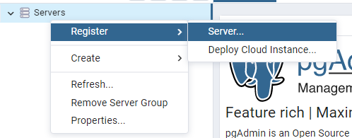

1. Name server

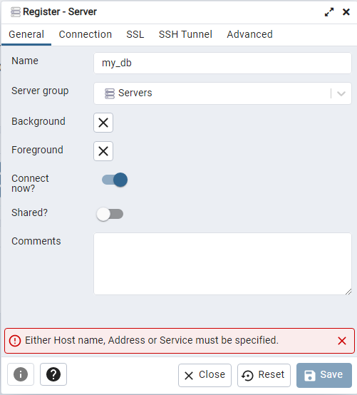

1. Find endpoint. E.g. RDS AWS and copy it on the connection tab

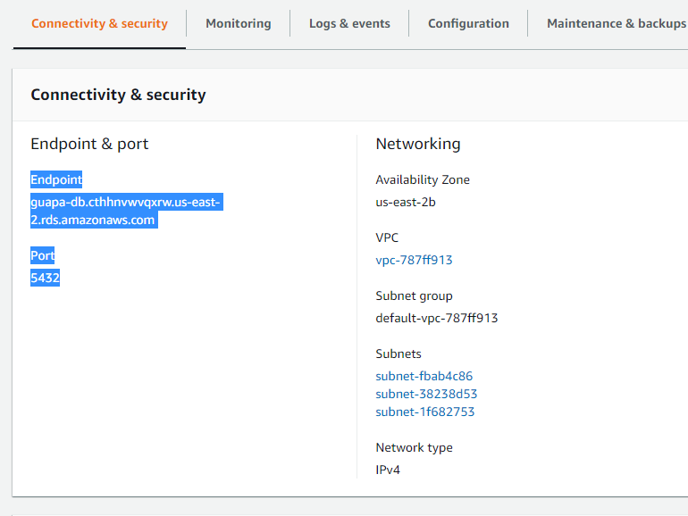

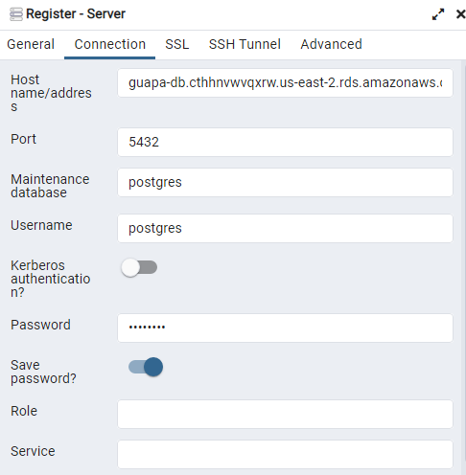

1. Upload and setup SSL Certificate on the SSL tab

